HLEBANI, FANELESIBONGE, (MR) (224672916)

BURAHE, SUDAIS, (MR) (224723367)

ADAM, SIBABALWE, (MR) (225094754)

The boys

Hlebani, Fanelesibonge, (Mr) (s224672916)

[Company name]

[Company address]

ITPV302 PROJECT

BUSINESS CASE

Table of Contents

1.1 Unsafe Communities and the lacklustre, fragmented crime reporting 3

1.2 Project Objectives 5

Improve communication in the community 5

Provide Verified Incident Records 5

Visualize Crime Trends through Maps 5

Support Vulnerable Populations 5

Enabling silent emergency alerts 5

Allow Evidence Collection 5

Generate Analytical Reports 6

Ensure Security and Privacy 6

Deliver Cross-Platform Accessibility 6

Strengthen Community Test 6

1.3 Problem Background 7

South Africa’s Crime Challenge 7

The Wider Impact 7

Community Responses 7

Digital Solutions 8

Ongoing Challenges 8

1.4 Related Systems Analysis 9

Crime Stopper 9

Crime Alert 9

SCP Emergency App 10

Namola 10

FEATURES TO INCORPORATE 11

FEATURES TO AVOID 11

1.5 The Project Plan 12

SafeZone 12

Project Foundation 12

Stakeholders 12

What Are We Delivering? 13

How Will We Deliver on Time? 13

Goals For the Project 13

Feedback 14

Project Roles For Team Members 14

Dependencies 15

1.6 Risk Analysis 16

Risk 1: Team Member Gets Sick or Leaves the Project 16

Risk 2: Technology Problems 16

Risk 3: The App is Too Complicated to Build 16

Risk 4: People Don't Like or Don't Use the App 17

1.7 Reference 18

COMMUNITY CRIME PREVENTION AND REPORTING SYSTEM

The purpose of this document is to justify the development of a community crime prevention and reporting system. It exposes the crime experienced in communities, the domain in which this crime exists, the people who are affected, and the objectives this system seeks to solve. We aim to demonstrate its societal value by defining the serious need for this real-world solution, and that it is often overlooked.

# 1.1 Unsafe Communities and the lacklustre, fragmented crime reporting

In many towns and neighbourhoods, a troubling truth is becoming clear. Crime is no longer just something we see in the news now and then, it has become a constant part of daily life. People live with the fear of theft, break-ins, or even violent attacks. This kind of fear does more than just cause financial loss, it slowly breaks down trust and community spirit. Neighbours grow suspicious of one another, parents feel unsafe letting their kids play outside, and even at home, people don’t always feel safe. A strong sense of togetherness that once kept communities close begins to fall apart, leaving behind loneliness and fear.

Making this problem worse is an uncomfortable truth: the very systems we depend on to fight crime are themselves broken. Reporting and sharing crime information is messy and poorly organised. When a crime happens, there is no single clear way to alert everyone. Some people call the police. Others post warnings on Facebook or share urgent messages in WhatsApp groups. More old-fashioned ways still exist too, like calling a neighbour, telling someone at the shop, or waiting for the story to appear on the news or radio later in the day.

This scattered way of spreading news, while done with good intentions, doesn’t work well. It’s slow, unreliable, and often spreads wrong information. Important details don’t always reach everyone in time, which leaves big gaps in awareness. In the absence of clear facts, rumours quickly take over. For example, a stranger standing on the street can easily be labelled as an armed robber online, causing panic. Because of the delay in getting the right details out, small crimes that could have been handled quickly often grow into bigger problems before help arrives. Most people at risk are the elderly neighbours, families with small kids, or people with disabilities. These people end up being the ones left most exposed.

The root of this problem lies in how poorly connected the community safety system is. This is especially serious in townships, suburbs, and rural areas where crime is already higher, and distance makes things harder. The real crisis is one of coordination. The three main groups meant to keep people safe don’t work well together. These groups are the police, neighbourhood watch groups, and everyday residents. In some places, there aren’t even neighbourhood watch groups at all, which leaves huge gaps. With everyone working separately, efforts overlap, messages get mixed, and overall safety becomes far weaker.

This issue isn’t just theory, it directly affects people in daily life:

* **The Worried Resident:** This person lies awake at night, scared for their family and home. They want to help but don’t know who to trust or what to do, other than locking their doors and hoping nothing happens.
* **The Frustrated Neighbourhood Watch Volunteer:** These are the people giving up their time to patrol the streets. They want to protect others, but poor communication makes their job nearly impossible. Often, information comes too late, or it isn’t detailed enough to be useful. Without the right tools, they can’t verify reports quickly, and so their efforts don’t always make the impact they hope for.
* **The Stretched Police Force:** Police officers get hit with late reports and a flood of unconfirmed tips across many different platforms. They spend too much time trying to figure out what’s real and what’s not, instead of focusing on stopping crime. This slows them down, lowers their success, and weakens their relationship with the community.
* **The Forgotten Vulnerable:** Older people, those who live alone, or anyone without access to digital platforms are often overlooked. Some don’t want to "be a bother," while others simply don’t get the message in time. This leaves them open to danger and turns their homes into easy targets.

At the end of the day, crime continues not only because of criminals, but because of the lack of unity in the system. The police, the residents, and the community groups are fighting the same battle, but all on different pages. Until these groups are properly connected and working together, crime will always have the upper hand. The way forward is not only about staying alert, but also about finding smarter ways to unite people, creating one strong front in the fight for safety.

# 1.2 Project Objectives

Real-world issues that will be addressed by our system:

Improve communication in the community  
**The Simple Idea:** Create one main hub for all safety information.

**How it Works:** Instead of using social media, phone calls, and texts, everyone can use this one app. Residents and neighbourhood watch groups can report problems, share concerns, and organize a response together in real time.

## Provide Verified Incident Records

**The Simple Idea:** Stop the spread of rumours and false information.

**How it Works:** Every report in the system will automatically record the exact timeandlocation.This "geo-tagging" and "timestamping" make the information reliable and useful for everyone.

## Visualize Crime Trends through Maps

**The Simple Idea:** Show people where trouble is happening on a map.

**How it Works:** The app will have a map that shows recent crime reports. This helps everyone see which areas are high-risk, so they can be more careful and avoid trouble.

Support Vulnerable Populations  
**The Simple Idea:** Make sure elderly or vulnerable residents are not forgotten.

**How it Works:** The system can help keep track of neighbours who live alone and might need help. It can send reminders to community members to check on them regularly.

## Enabling silent emergency alerts

**The Simple Idea:** Let people call for help without making a sound.

**How it Works:** If you are in danger, you can tap a button on your phone. The app will silently send an alert to nearby neighbours and the police. It will automatically include your live location so they can find you quickly.

Allow Evidence Collection  
**The Simple Idea:** Make it easy to safely share photos or videos of crimes.

**How it Works:** If someone sees something suspicious, they can upload pictures or videos directly through the app. This gives the police and the community solid evidence to work with.

Generate Analytical Reports  
**The Simple Idea:** Use data to make smarter safety decisions.

**How it Works:** The system will create simple reports and charts showing crime trends. This helps police and neighbourhood watch groups decide where to patrol and how to best use their resources.

Ensure Security and Privacy  
**The Simple Idea:** Protect everyone's personal data.

**How it Works:** The app will use strong security (like encryption) to keep user information safe. A secure login ensures that only trusted community members can access the system.

Deliver Cross-Platform Accessibility  
**The Simple Idea:** Make sure everyone can use it, no matter what phone or computer they have.

**How it Works:** The system will be both a mobile app and a website. This means people can use it on smartphones, basic phones, or computers, making it inclusive for all.

Strengthen Community Test  
**The Simple Idea:** Bring people together to look out for each other.

**How it Works:** By working together on safety, the system will build unity, trust, and a shared sense of responsibility for protecting children, the elderly, and the entire neighbourhood.

# 1.3 Problem Background

## South Africa’s Crime Challenge

South Africa is among the most dangerous countries in the world, with a crime rate reaching 75.4% on its way to 80%. Crime in South Africa remains as one of the defining challenges of life in South Africa that doesn’t discriminate. Regardless of the location, households and individuals continue to face the risk of break-ins, robberies, theft, and other crimes that disrupt daily life (Stats South Africa, 2025).

In the first few months of the year, over 5000 murders have been reported with a rate of 75.5 people per day as of 2024-2025, than other years, highlighting the persisting severity of security crisis (Times Live, 2025). When looking at individual theft or personal property, it was the most common crime in the past years, with about 1.2 million people affected in communities. The people who live alone are almost the perfect target of crime, as they can’t even scream out or get help from anybody.

These significantly high numbers of crime often lead to anxiety, social withdrawal, and reduced communication among residents, which negatively affects the community's trust and the willingness to engage with one another in activities or in other aspects. This increase in crime makes communities decline with individuals seeking to move, especially those with the financial means, to safer environments, leaving behind the vulnerable people with less resources, leading to urban decay and weakened local economies (Meyer & van Graan, 2011).

Fear of crime isolates people in communities which deteriorates the well-being of the community which makes it worse on the individuals who live alone or those who just moved in the community they already feel isolated, which makes them good targets for criminals as they won’t have people to cry out to or seek help from. This would also make them reluctant to report the crime for fear of what might happen next.

## The Wider Impact

The impact of such crimes extend beyond the immediate victims and the community members. Disruptions could happen in school, exposing children to violent crimes, trauma and the social instability which can hinder their development. By addressing the impact of crime on individuals and the community we can create a better future for generates to come. (HealthMag, 2023).

Often reporting a crime may not lead to meaningful action and they are less likely to enage with the community safety initiatives further reinforcing a cycle of underreporting and ineffective prevention (UNODC, 2022).

## Community Responses

To cope with the mentioned challenges, communities often develop safety mechanisms, such as saving each other's contact info, WhatsApp/Facebook groups, patrols, and neighbourhood watches. These approaches are solid but quite limited. Not many people in communities will have airtime to call or make an SMS request. Communication in messaging groups is often cluttered, unverified, or delayed, making it difficult to respond effectively to emergencies.

The spread of misinformation is a major concern with messaging because it could also be outdated. The same thing can be said about neighbourhood watches, they often require resources which is limited, there’s a lack of coordination, and also the absence of tools for information sharing to make it easier for them to act in case of emergencies.

CPF (Community policy forum) programs also help communities cope with the challenges by identifying a community organisation, e.g., Churches, schools, businesses, and unique social gatherings are such examples which brings together community members and police officials to promote community safety (Studocu, 2024).

## Digital Solutions

Bridging this gap has emerged through digital solutions providing platforms to help citizens report quickly and effectively. Platforms such as the SCP emergency app, Namola, and Crime Stopper provide citizens with tools for incident reporting, crime mapping, and fast emergency assistance.

For instance, the SCP Emergency App includes all SCP security services, granting the user free and quick access to a national network of Security, SAPS, Medical, and Fire Response Units available 24/7, while Namola allows users to alert emergency responders with a single tap (Cape Business News, 2021; Namola, n.d.).

These innovative platforms demonstrate how technology improves response times and awareness. They lack the necessary reliance on smartphone access, they don’t include the elderly or low-tech users, and they focus solely on individual safety rather than being community-driven.

## Ongoing Challenges

The community's collective well-being is often undermined by individuals only focusing on the individual, and the issues are often fragmented. This manifests in an increased reliance on private security companies, leaving poorer communities exposed and isolated (van Steden & Mehlbaum, 2022).

Crime is not merely a law enforcement issue but a societal problem that affects mobility, mental health, and community cohesion. To address these issues, platforms that are easily accessible and enable collaboration between the community, rather than relying on word of mouth or informal messaging groups, are essential. These centralized systems streamline communication, organize efforts, and ensure that information reaches all members simultaneously, preventing critical details from being lost in fragmented conversations.

We aim to bring a solution that counteracts community decline by rebuilding trust, improving neighbour communications, and empowering residents to get themselves in the activities of the communities.

# 1.4 Related Systems Analysis

## Crime Stopper

**Platform:** iOS & Android

**Description of the System:**  
The system is a free, map-based reporting and alert system that enables South Africans to report crimes or suspicious activities and view them on the map in real-time. Users can log occurrences with optional photos, descriptions, and location data, nearby community members, and so on. The system seeks to overcome the fragmentation of WhatsApp groups by centralizing incident data and promoting structured, location-aware communication. Its core functions include incident recording, crime mapping, and real-time push notifications within a set radius. The app aims to strengthen neighbourhood safety efforts by improving awareness and coordination between residents and law enforcement without replacing formal police reporting channels (CrimeSpotter, n.d.; Cape Business News 2021).

Figure : GPS-Integrated Screen

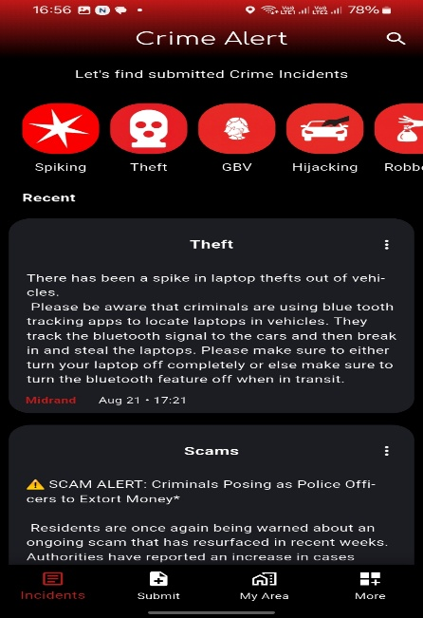

## Crime Alert

**Platform:** iOS & Android

**Description of the System:**  
The system enables users to submit crime incidents all over the country, ensuring that communities can contribute to spreading the word. You can get notifications based on your surroundings using your location. It doesn’t serve as an app that constitutes an official police report and is not a substitute for contacting law enforcement. The app is simply intended for informational purposes only.

Figure : Incident Reports screen

Integrated Screen

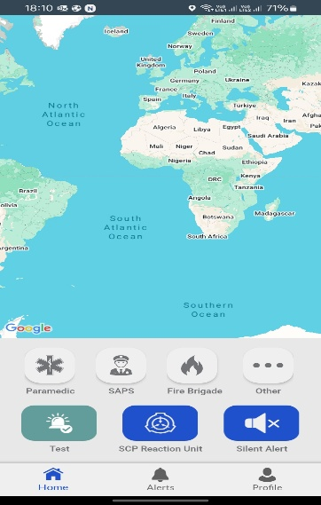SCP Emergency App  
**Platform:** iOS & Android

**Description of the System:**  
The App is one of South Africa’s most responsive emergency applications. It provides users with 24/7 service access to the national security of SAPS, medical, and fire response units through GPS integration. Users can instantly alert them at the touch of a button, automatically sharing their precise location with SCP. Ensuring that even if users are unable to speak or give directions, responders can be dispatched within a few minutes. This app functions by combining multiple services into one platform improving coordination while reducing response times (SCP Emergency App, n.d.).

Figure : First EMR Screen

screen

Integrated Screen

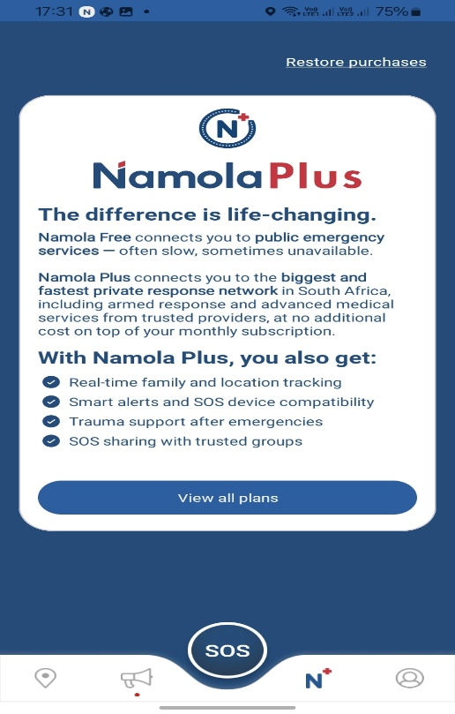Namola  
**Platform:** iOS & Android

**Description of the System:**  
The app connects users to police, ambulance, and private emergency services through GP-related alerts. It is designed for personal safety emergencies rather than for community-level reporting. A key feature is its “Track Me” function, where users can share their live locations with trusted contacts. Namola also allows for silent alerts in situations where speaking may be unsafe during hijacking or robbing. (Namola, n.d.)

Figure : SOS Emergency button alert

screen

Integrated Screen

## FEATURES TO INCORPORATE

From reviewing these systems, the following features stand out as valuable and will be adapted into our systems.

* **One-tap SOS Activation:** it calls the user and routes requests to nearby responders. (Google Play, 2025; Civic Tech Innovation Network, 2022)
* **GPS-enabled location:** allows users to share their locations for fast and accurate for accurate and fast emergency response.
* **Community safety groups:** enable users to join local communities to send and receive safety updates without the randomness of group messaging, and most importantly, to strengthen communication and collaboration among neighbours. (Support centre, Namola, n.d.)
* **Photo/Video evidence capture**: to improve the accuracy of information and support law enforcement.
* **Incident Screen (from Crime Alert):** where users can share current incidents to one another.

## FEATURES TO AVOID

* **Delayed communication** with the law enforcement, as seen on apps like CrimeStopper.
* **Over-reliance on smartphone access (**as seen on SCP Emergency App and Namola) this excludes the elderly and the low-tech users.
* **Complicated User Interfaces:** this makes it difficult for older or less techy residents to navigate through the apps which stresses them out.

# 1.5 The Project Plan

## SafeZone

In this section, a comprehensive project management plan and the deployment of our mobile application will be defined, the project scope, its goals, timeline, and how it will be executed.

At the end of the roadmap, the stakeholders and the academic requirements of the ITPV302 module will be met. The following plan will detail the structure of the team, strategic goals, and a roadmap (Gantt chart), which will help provide a clear solution on how our previously proposed solution will be delivered in the given time frame.

## Project Foundation

The client, in this case the neighbourhood watch, and community need a secure and quick digital platform that isn't like the current available communication platforms, such as WhatsApp or Facebook, that could be used to report crimes and make emergency alerts.

The goal is to centralize the process of connecting and reducing emergency contact times and improve community safety. The end goal is to have a unified, verified, live location-aware platform that also has reporting capabilities, instant alerts, and a communication platform for community groups.

The decision-making process will follow a collaborative approach from all the team members, but the project manager will have the final say in all the decisions and executions, while the lecturer, Dr. Chinonye, will provide feedback during the consultation meetings that will be held biweekly.

There are several issues that can delay the success of the project if not managed well like balancing coursework with the development of the project. Compared to companies with a budget, we are quite limited at what we can do with restricted tools, devices and infrastructure. Overplanning by going beyond the scope by adding too many features beyond the MVP might make the system unmanageable within the timeframe. Feedback from the community may be limited to a few members of different communities, our friends, lecturers, and surveys we send out in the form.

Despite these constraints, the project will continue as is and remain successful under the requirements of the project. Demonstrates the ability to solve a real-world problem through system design and the implementation of the system.

## Stakeholders

**Client:** neighbourhood watch community leader

**End-Users:** community members, neighbourhood watch services

**Academic Lecturer:** Mr. Vuyo

**Project Team:** Sudais, Adam, Fanele

## What Are We Delivering?

By the end of the cycle, we will have a minimum viable product (MVP), which is a mobile application that is designed to help improve community safety, Safe Zone.

The core tasks include:

* A functional mobile application with user registration and authentication while ensuring the confidentiality, integrity, and availability of the user's information.
* A reporting system with photo, video, and GPS location tagging.
* An emergency button for specific emergencies, such as a fire or burglary.
* A chat room for community members within the same communities.
* An interactive map showing a heatmap of alerts and incidents.
* A dashboard for the admin to manage the users and reports.
* Complete project documentation as given in the module requirements.
* Community notifications and watch group coordination
* Offline SMS option for non-smartphone users.
* Cross-Platform mobile App

## How Will We Deliver on Time?

We will be using an agile approach that has an iterative development cycle that is focused on the core functions of the MVP before adding improvements and enhancements. A flexible schedule that aligns the development cycle with the academic submissions will be used to allow for a parallel workflow.

A continuous risk assessment will be undertaken to help identify challenges that may be faced while also providing time for troubleshooting. Regular check-ins will be made through GitHub and Google Docs to keep track of task completions and have weekly meetings, and if needed, emergency Zoom meetings.

## Goals For the Project

**Problem proposal and Information gathering** (Month 1)

Propose the idea that we want to build. Research the communities by conducting surveys about their experience with crime challenges and collect requirements from stakeholders (community, police, neighbourhood watch groups, and lecturers)

**Requirements Gathering & Planning** (Month 1)

We must decide on what the app must do, design the database, and agree on the main goals of the system.

**Design Phase** (Month 1-2)

The creation of the system’s layout. Drawing storyboards and deciding what we want in a screen and choosing the tools.

**Prototype Building** (Month 3-4)

We will create a simpler working version of the final build with your login, alerts, and basic reporting.

**Main Development of the App** (Month 2-3)

This is where we’re going to add full features like GPS alerts, community notifications, and the reports section.

**Testing & Feedback** (Month 4)

App testing to get feedback from surveys, then improve it.

**Final Launch** (Month 4)

An app release and a web version that will guide users.

**Support & Updates** (After Launch)

Fix problems and improve security.

## Feedback

Feedback is an important part when developing the system, as it ensures that the system addresses community concerns and that the system is practical.

**Community surveys** – feedback will be collected in the community via questionnaires to provide clearly the issues faced in the company and outline how we could fight against crime in the community.

**Module lecturer** – continuous input from the lecturer who is responsible for the Project Module to ensure that the project system applies the necessary principles effectively.

**BIT Coordinator** – Consultation with the senior lecturer who provides feedback on the scope and feasibility of the project

The team will communicate via Teams/Zoom, WhatsApp, and email, and GitHub will be used as a version control tool to help with the development of the application, coupled with live weekly meetings for the core members to sync up.

Feedback will heavily influence the development of the system, allowing us to refine features, simplify them, and ensure the system aligns with community needs.

This is a team that collaborated on previous projects for modules like IMOB301, IRUD301, and IAPP301, delivering working solutions to the tasks and problems that were faced.

## Project Roles For Team Members

The project team is made up of 3 members who will take on responsibilities to ensure a successful delivery:

1. **Project manager:** Fanele
2. **UI/UX designer:** Sudais and Fanele
3. **Frontend Developer:** Sudais and Fanele
4. **Backend Developer:** Sudais, Fanele, and Adam
5. **Quality Assurance Tester:** Adam

These roles may be done by more than one member, as this is an academic project, and multiple people may share responsibilities.

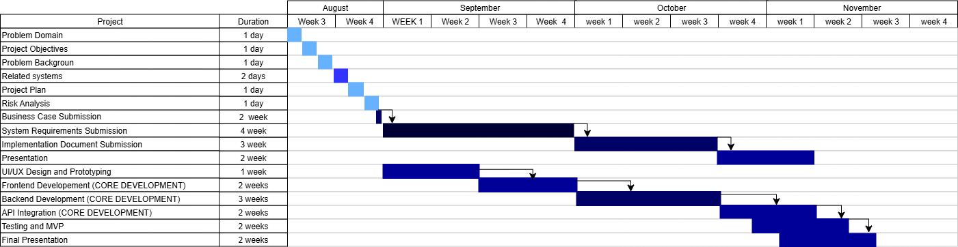

*Figure 5: Gantt Chart*

screen

Integrated Screen

## Dependencies

* The database design must be completed before backend development.
* The core login/user registration system must exist before reporting alerts.
* Before testing, prototyping must be completed.
* Gathering of information before the design phase will be implemented.

# 1.6 Risk Analysis

A risk is something that could go wrong and mess up our project. We've identified four main risks that could happen. For each one, we explain what it is, what kind of risk it is, and our simple plan to deal with it.

## Risk 1: Team Member Gets Sick or Leaves the Project

**What could happen?** One of us (Sudais, Adam, or Fanele) could get sick, have too much other schoolwork, or even decide to leave the project. This would mean fewer people to do the work, which could cause big delays.

**Type of Risk:** Minimizable Risk

**How we will handle it:**

* Share the knowledge: We will all work on different parts of the app together, so no one person is the only one who knows how to do something important.
* Keep a shared diary: We will use Google Docs to keep notes on what we are doing and how we are doing it. This way, if someone is absent, the others can easily pick up where they left off.
* Talk regularly: We will have weekly meetings to check if anyone is feeling overwhelmed so that we can help each other out early.

## Risk 2: Technology Problems

**What could happen?** Our computers could break, the internet could go down for a long time, or the online services we use (like our database) could have problems. This would stop us from being able to work or could even cause us to lose some of our code.

**Type of Risk:** Avoidable Risk

**How we will handle it:**

* Always back up our work: We will use GitHub to save our code every day. GitHub is like a safe online vault for our project. Even if all our laptops break, our code will be safe online, and we can get it back.
* Have a Plan B: We know which coffee shops or libraries have good Wi-Fi if our internet at home fails.

## Risk 3: The App is Too Complicated to Build

**What could happen?** We might plan to build a feature that is much harder to create than we thought. We could get stuck trying to make it work and waste a lot of time, meaning we don't finish the rest of the app.

**Type of Risk:** Minimizable Risk

**How we will handle it:**

* Start simple (MVP): We will first build a very simple version of the app that only has the most important features, like reporting a crime and sending an alert. This is called a "Minimum Viable Product" or MVP.
* Add features later: Once the simple version is working, we can then add the extra features (like heat maps or chat rooms) if we have time.
* Ask for help: If we get stuck on a technical problem, we will not waste time. We will ask our lecturer, Mr. Vuyo, for advice.

## Risk 4: People Don't Like or Don't Use the App

**What could happen?** Even if we build a perfect app, the people in the community might not find it easy to use, or they might not trust it. If no one uses it, our project doesn't help anyone.

**Type of Risk:** Acceptable Risk (But we will still try to minimize it!)

**How we will handle it:**

* Keep it simple: We will design the app to be very easy to use, with big buttons and simple menus, so that even people who are not good with technology can figure it out.
* Get feedback early: We will show our app design to a few stakeholders (like our client, the neighbourhood watch leader) as soon as possible to see if they like it. We can change our plans based on their feedback.
* We accept that we can't force people to use the app. For this university project, our main goal is to build a working system that could help a community. If people use it, that's a bonus!

# 1.7 Reference

* Cape Business News. (2021, May 21). *Crime reporting and alert app launches in South Africa*. Retrieved from [https://www.cbn.co.za/featured/crime-reporting-and-alert-app-launches-in-south-africa](https://www.cbn.co.za/featured/crime-reporting-and-alert-app-launches-in-south-africa?utm_source=chatgpt.com)
* CrimeSpotter. (n.d.). *How it works*. Retrieved from [https://crimespotter.co.za/how-it-works](https://crimespotter.co.za/how-it-works?utm_source=chatgpt.com)
* Govender, D. (2020). *Reflections on community-based participation to reduce violent crimes in South Africa.* *African Security Review, 29*(4), 316–329.
* Lancaster, L. (2017, March 6). *Why are South Africans underreporting on crime?* ISS Today. Retrieved from [https://issafrica.org](https://issafrica.org/)
* Meyer, M., & van Graan, J. G. (2011). *Effective community policing in practice: The Roodekrans neighbourhood watch case study, West Rand.* *Acta Criminologica.*
* Namola. (n.d.). *How Namola works*. Retrieved from [https://namola.com](https://namola.com/)
* SAPS. (2023). *Crime statistics 2023/24*. South African Police Service.
* UNODC. (2022). *Community-based crime prevention: Global practices and lessons learned*. United Nations Office on Drugs and Crime.
* van Graan, J. (2016). *Multi-sector cooperation in preventing crime: The case of a South African Neighbourhood Watch*. *Police Practice and Research, 17*(2), 136–148.
* van Steden, R., & Mehlbaum, S. (2022). *Do-it-yourself surveillance: The practices and effects of WhatsApp Neighbourhood Crime Prevention groups.* *Journal of Crime Prevention.*
* SCP Security (2021). *SCP SECURITY EMERGENCY MOBILE APP.* Retrieved from[SCP EMERGENCY MOBILE APP | SCP SECURITY](https://www.scpsecurity.co.za/scp-emergency-mobile-app#:~:text=SCP%20Emergency%20App%20is%20South%20Africa%27s%20most%20comprehensive,Response%20units%2024%20hours%20a%20day%2C%20every%20day%21)
* Healthmag (2023). *Discussing the Impact of Crime on Individuals and Communities. Retrieved from* [*Discussing the Impact of Crime on Individuals and Communities - Health*](https://healthmag.co.za/2023/06/discussing-the-impact-of-crime-on-individuals-and-communities/)
* TimesLIVE. (2025, May 23). CRIME STATS | 5,727 murders in first three months of the year. *Retrieved from* [*CRIME STATS | 5,727 murders in first three months of the year*](https://www.timeslive.co.za/news/south-africa/2025-05-23-crime-stats-5727-murders-in-first-three-months-of-the-year/)